THIRD ASSIGNMENT – Part 2
Class diagram

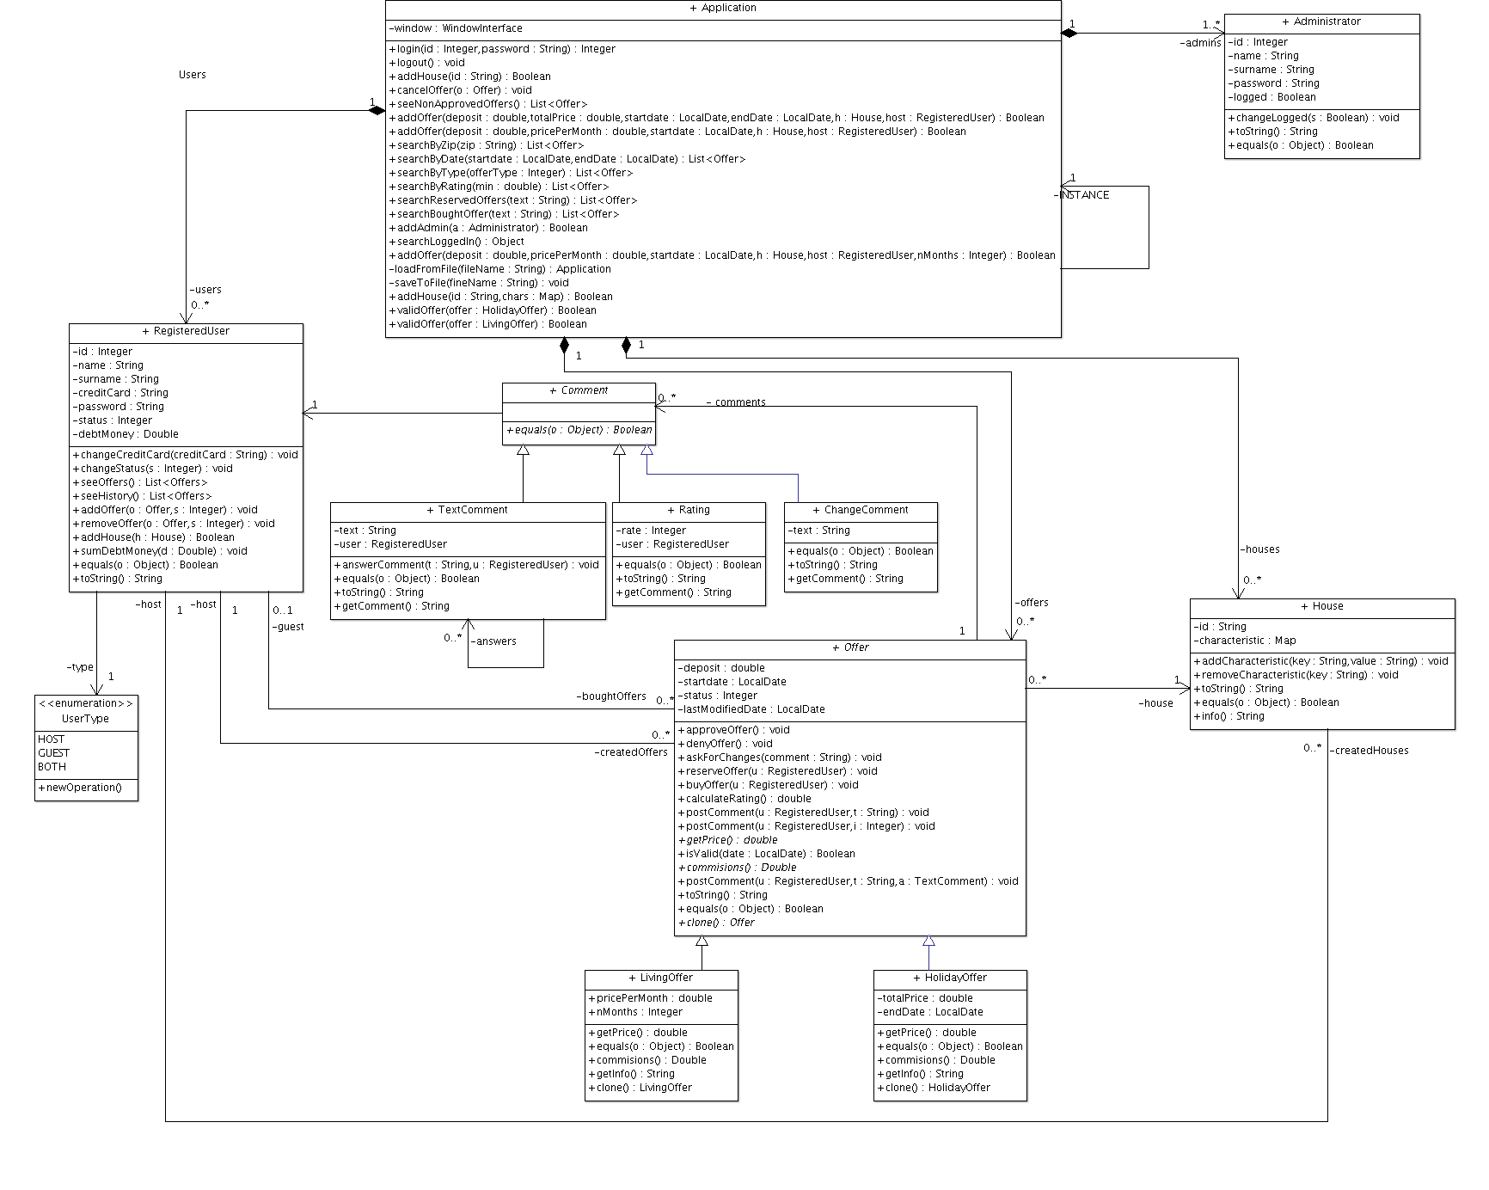
Traceability matrix
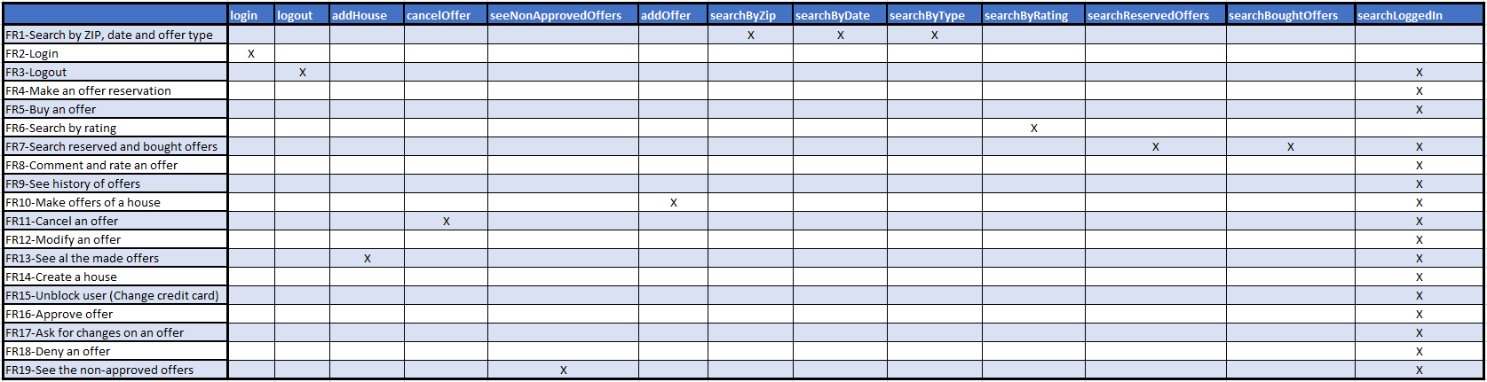
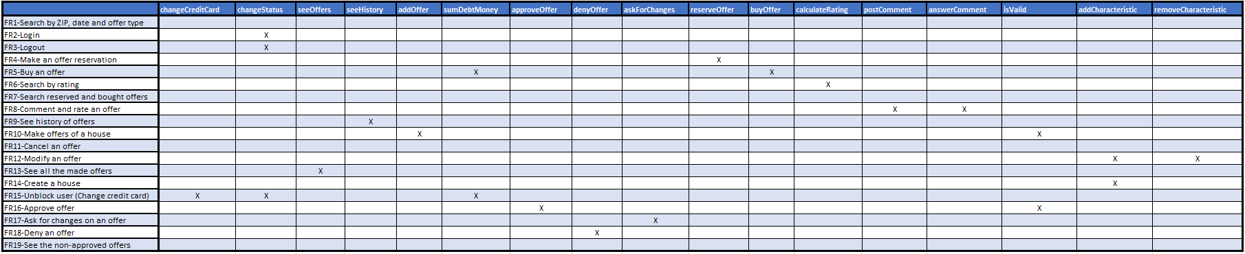

Information

First of all, in order to be able to run the project, you need to import the included library called TeleChargeAndPaySystem.
We have also included a backup file named data.obj which contains some created and bought offers, and some banned users. In order to test it, you just need to move that file into the main project folder, where initial_data.txt is.

To run the Application with its interface, you just need to execute Interface.java, which is in the default package, and once you do this, a list of the Application’s administrators and users’ information will be printed on the terminal, so that you can log directly using this data.

In order to make the interface more comprehensive, uniform, and fast, we decided to create an interface called WindowInterface, so that the classes who implement it have a secondary panel that can be changed.
With this, our app changes the panel (JFrame) just when you login/logout, and this panel is updated with different views (JPanels) depending on the action.

Finally, we wanted to comment that, as the main purpose of the houses is to create offers, we decided that you can just view, create or select houses when creating or modifying an offer.

